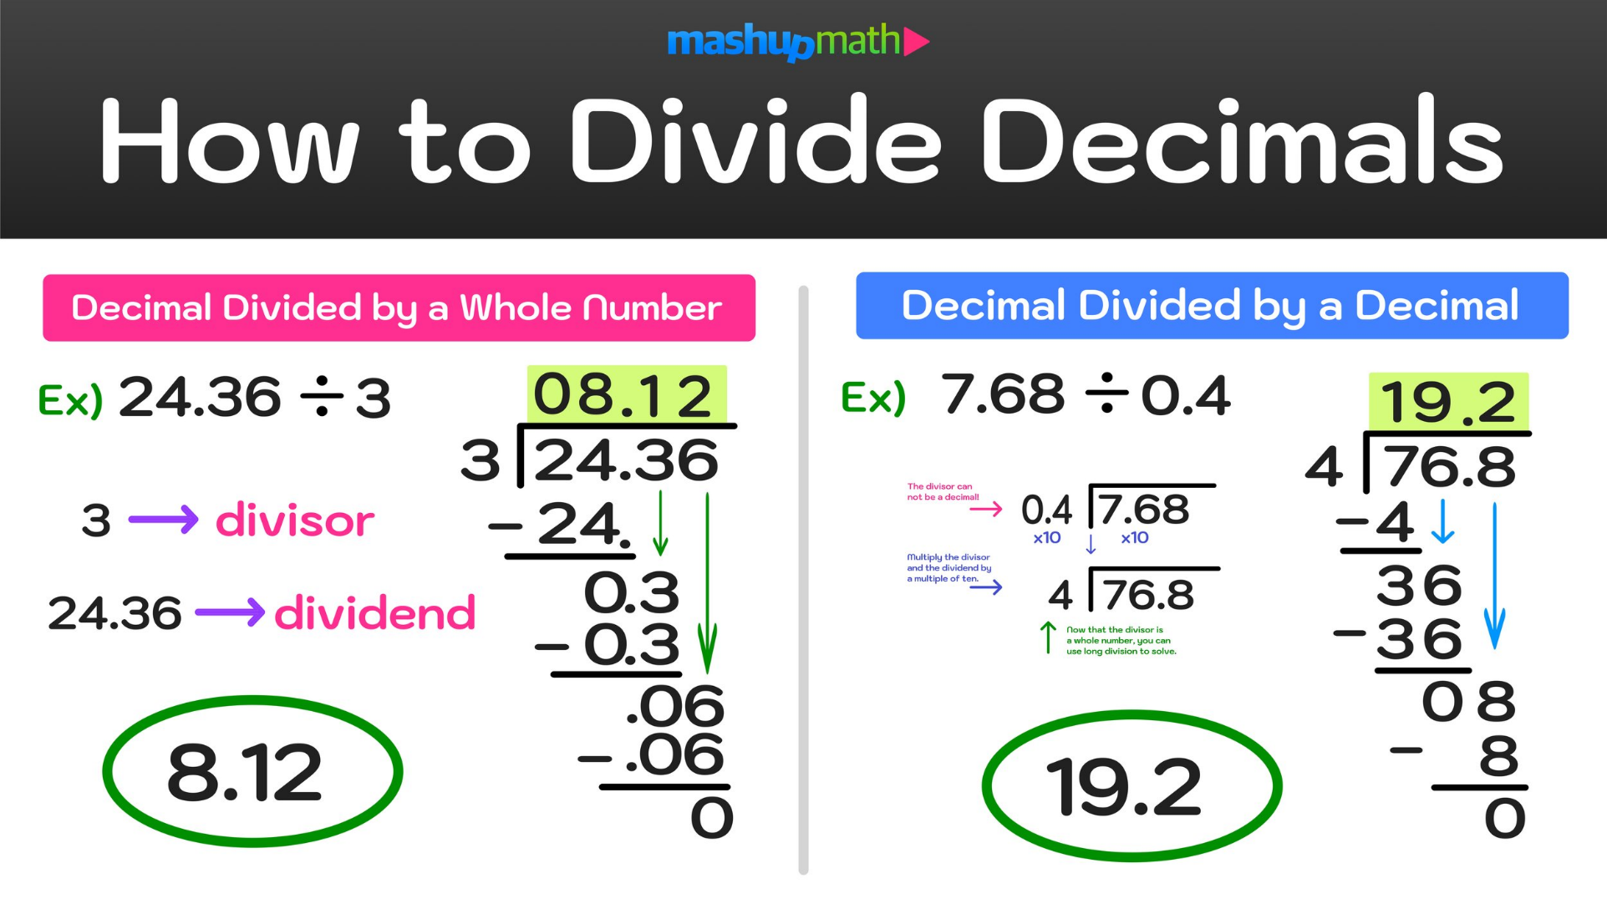

1. Move the decimal place over two places to the right in the divisor, and two places to the right in the dividend. You want to make the

divisor a whole number.

2.Now follow the same steps: divide, multiply, subtract, bring down, and repeat as necessary.